Guide to Using DE Gateway

Log in at https://degateway.gallatin.montana.edu/ and select Dual Enrollment Instructor:
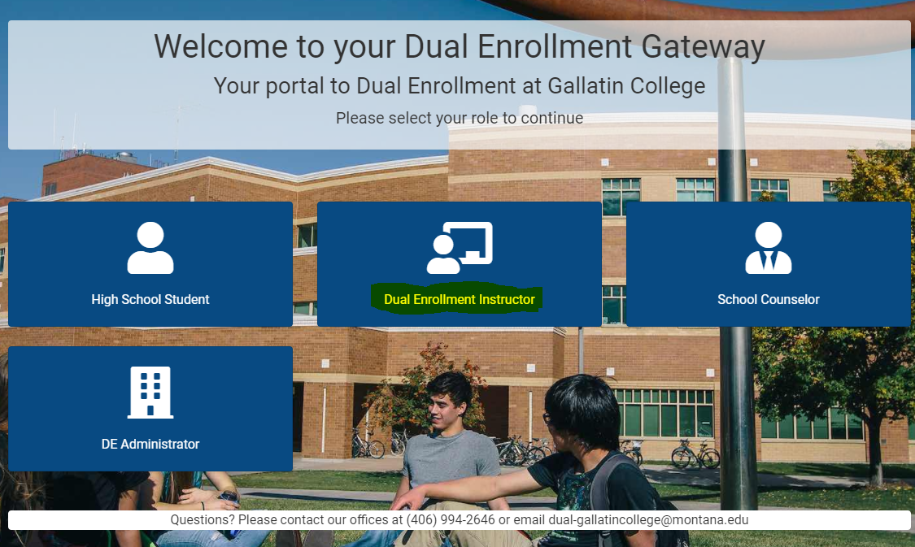

Follow instructions based on if you have your NETID or not; you need to use your MSU GID/eight digit ID number (if you don’t know your GID click on help or email the dual enrollment coordinator) to claim and set up your NETID and a NETID password if you have never accessed or used these credentials before.
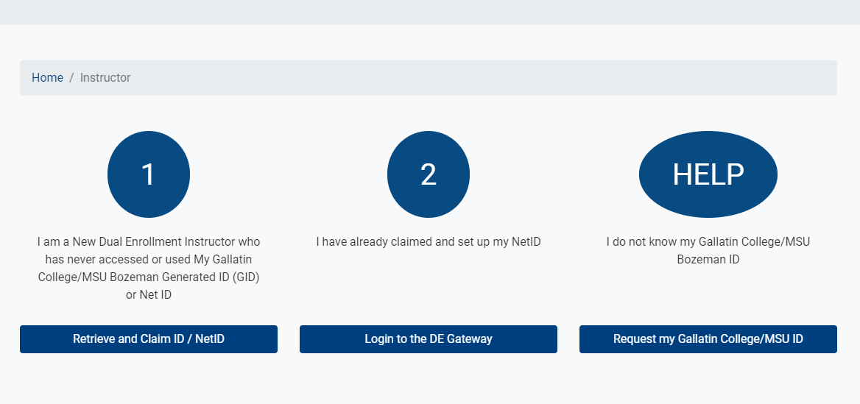

Home Page
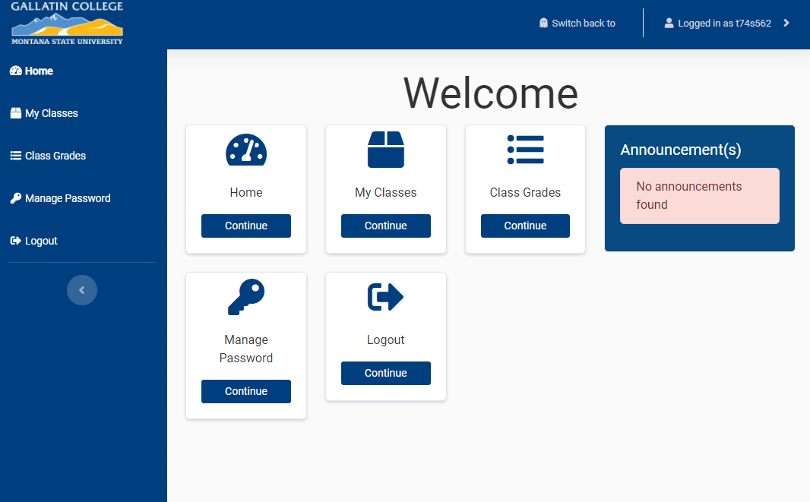

Once you’ve logged into the DE Gateway, you can review the courses you are assigned to in the My Classes Tile. This is where you will be able to see your classes, enter information about those classes, view your class roster, and upload your syllabus:
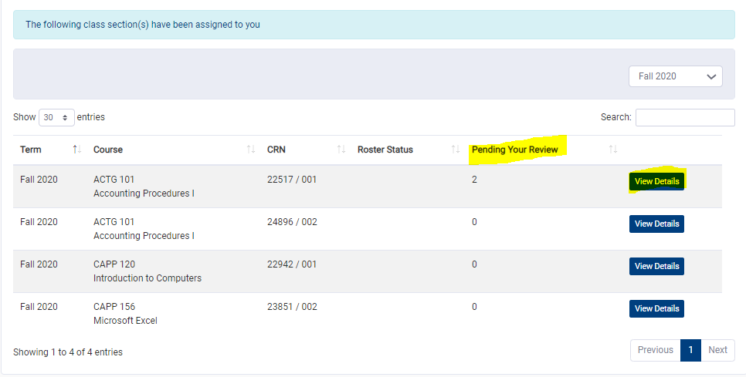
Class Information - It is important to enter this information as it helps the student locate classes during registration. There are four fields in the class section area. First is Period Time (see left side of screenshot below). Please enter the exact time of day the class runs or any specific lingo that your students will recognize in order to help them find and register for the correct section. Second is Free Period(s). This is more for internal purposes. If the DE Gateway staff needs to reach you, they can use this to find the most optimal time to schedule a call. Syllabus Upload - Please upload your syllabus (see the right side of the screenshot below). Upload the file from your computer, select the course it is associated with and click Add File. Class Roster: To approve students who have registered for your course, click on the Class Roster Tab:
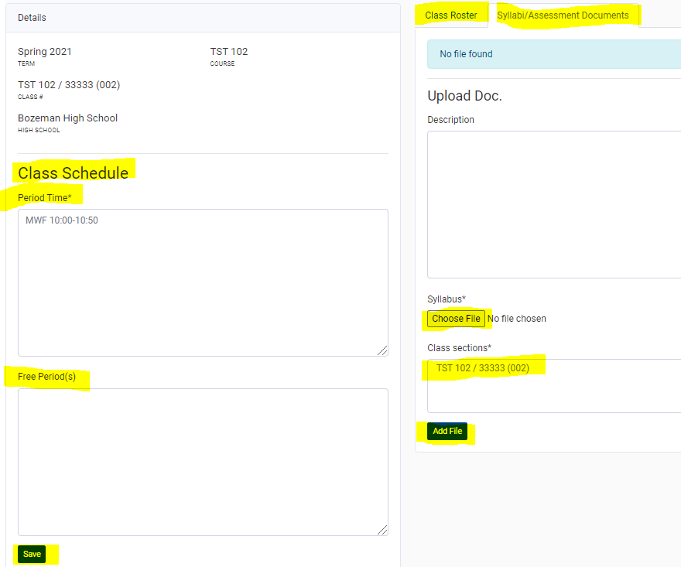

Class Roster Continued: You can approve or not approve each student on your roster, then click Submit:
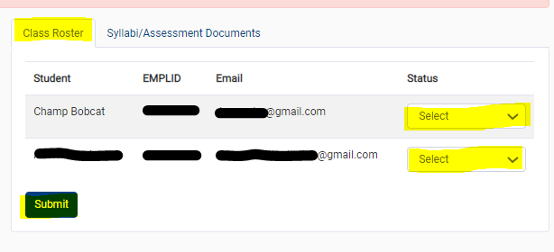

Entering Grades: Click on the the Class Grades Tile FINISH THESE INSTRUCTIONS
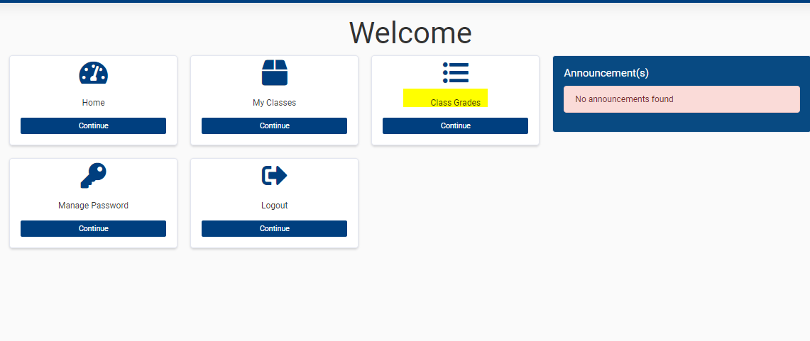

School Counselor Access and Approval
Log in at https://degateway.gallatin.montana.edu/ and click on School Counselor
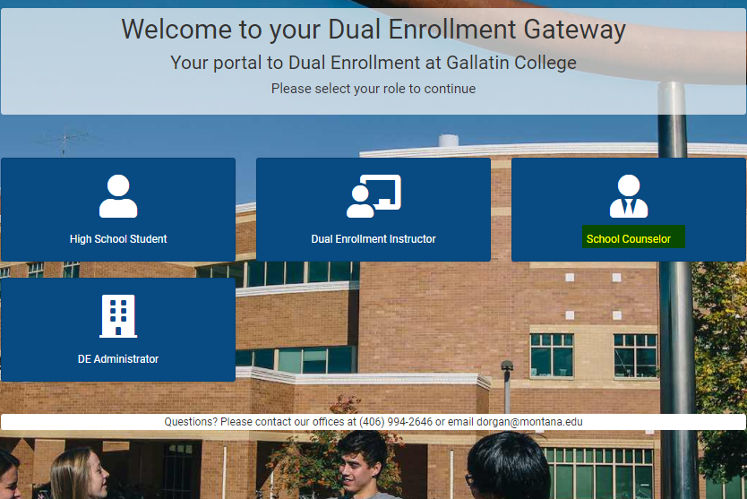

If you are new, Click on Submit Access Request and complete the form that will be sent to the DE Gateway team for approval. You will receive an email from them with further instructions. If you are returning, sign in with your email address and password that will be provided to you.
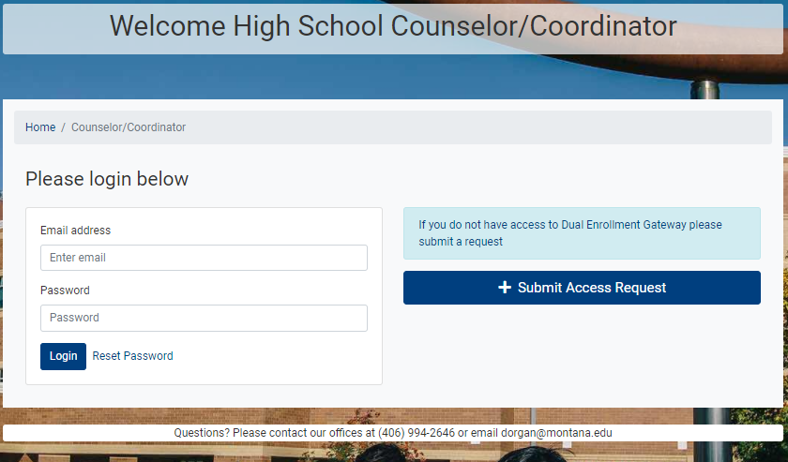

Your homepage will look something like this:
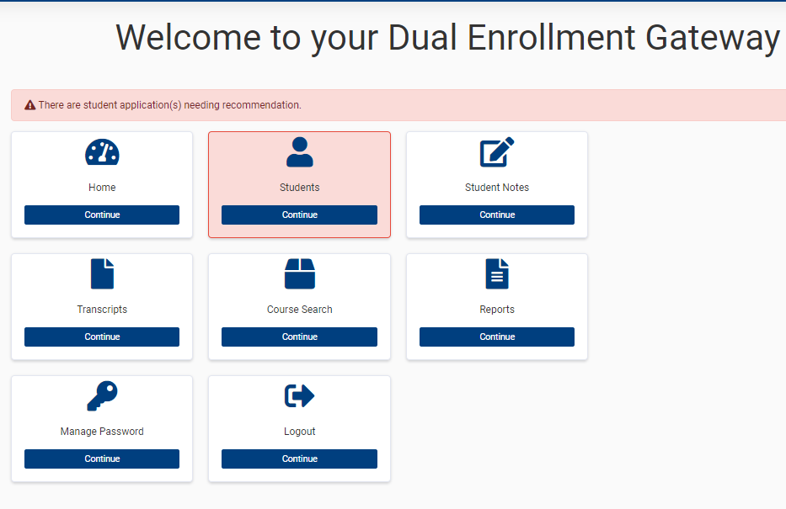
Click on the Students tile to view the status of your students. Then click on Submit Rec. to see the approval area:
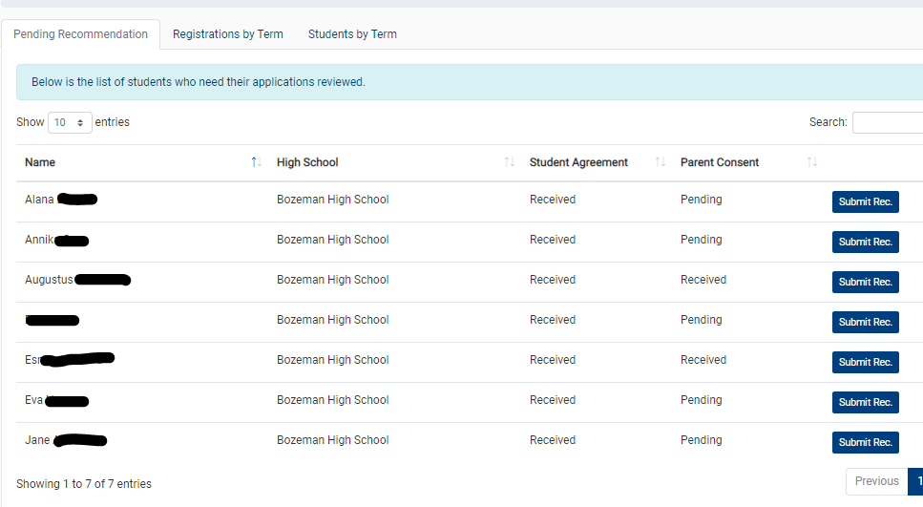

Select Approved or not Approved and click on Submit Recommendation:

